In-betweeners

Materials: 3 Dice, a pencil & paper
Players: 3 players
Objective: To create a number that is in-between the other players’ numbers. You do not want to have either the largest or the smallest number.

- Shake the dice well in your hand.
- Roll the dice onto your desk. Be sure to hide your dice from the other players.

- Form a three (3) digit number with your dice that you think will be in-between the other players’ numbers.

- Once everyone has created their numbers, reveal your number. Did you make the in-between number?

- The player who creates the in-between number receives one point. The first person to get three (3) points wins.

- Record your number on your piece of paper.
- At the end of the game, place your numbers in order from least to greatest.

Variations of the game:
Use decahedron (0 to 9) dice to make: Numbers to 10, use (1) one die
Numbers to 100, use (2) two dice
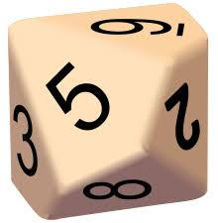
Numbers to 1000, use (3) three dice
Numbers to 10 000, use (4) four dice

