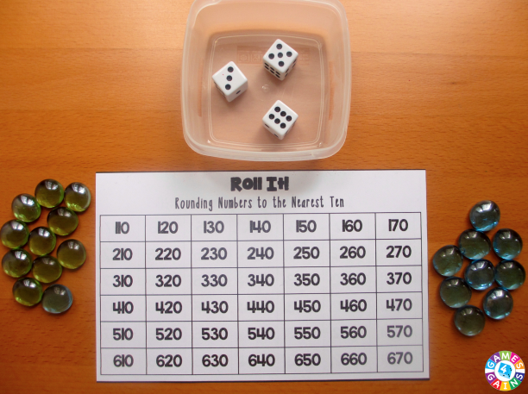
Materials needed:
- Roll It! Rounding Game Boards (see below)
- Dice (the number of dice needed depends on the game level being used)
Rounding Numbers to the Nearest Ten = 3 dice
Rounding Numbers to the Nearest Thousand = 5 dice
Rounding Numbers to the Nearest Hundredth = 3 dice
- Cup for holding the dice
- Small counters or beads

Playing the game:
Object of the game: To be the first player to make a line of four in a row (horizontally, vertically, or diagonally) on the game board.
Number of players: 2
1. To decide who goes first, each player rolls one of the dice. The player with the highest roll goes first.
2. On your turn, roll all of the dice. I like to have my students roll the dice into a small plastic container so that the dice don't roll onto the floor.
3. Use all of the dice that you just rolled to create a number. You may place the dice in any order to create the number. For example, if you rolled 4, 1, and 6, you may create 416, 461, 146, 164, 614, or 641.
- If playing "Rounding Numbers to the Nearest Ten," you'll create a 3-digit number.
- If playing "Rounding Numbers to the Nearest Thousand," you'll create a 5-digit number.
- If playing "Rounding Numbers to the Nearest Hundredth," you'll create a 3-digit decimal by placing a decimal point in front of all 3 digits (i.e. no whole numbers).

4. Depending on the game that you are playing, round the number that you created to the nearest ten/thousand/hundredth. Then, place one of your counters on top of that number on the game board. If your opponent's counter is already on that number, you may not place your counter on the game board.

Some examples:
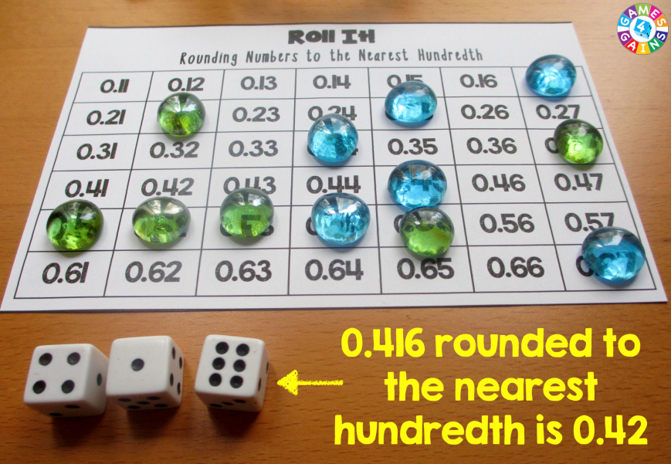
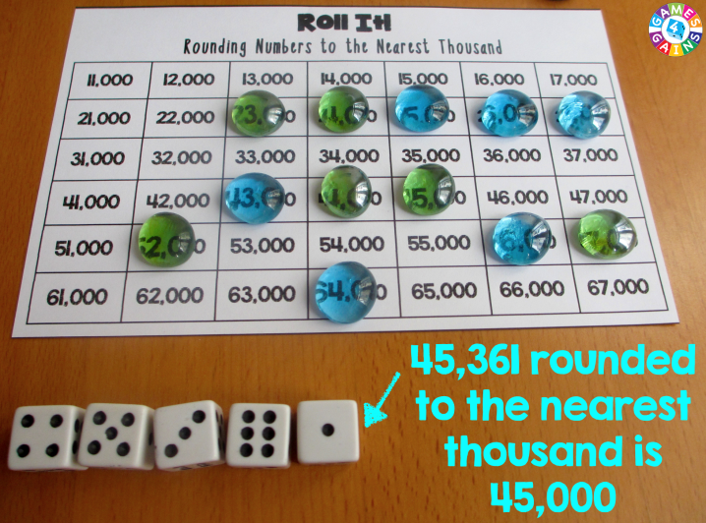
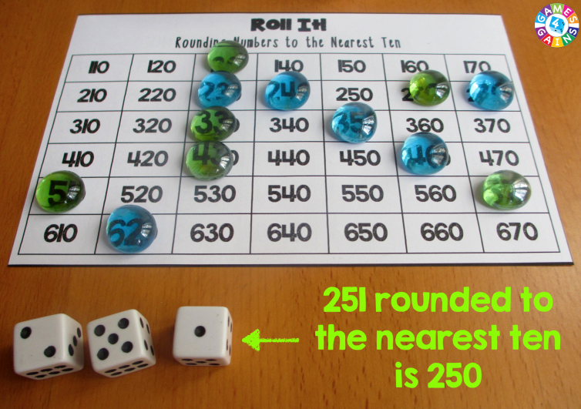

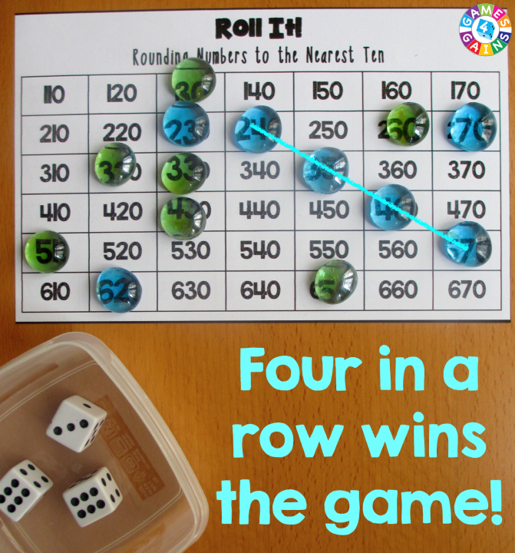

5. Players continue taking turns until one player creates a line of 4 in a row of his/her own counters on the game board.

