- Start by listing all the numbers from 1 to 30.
- Pick 4 numbers (your choice) from the list. Cross or “scratch” them off the list.
- Using only these four numbers, create math problems that add, subtract, multiply, divide or any combination of these, to “scratch” off the remaining numbers one at a time. You can only use each number once in each math problem you create (see below).
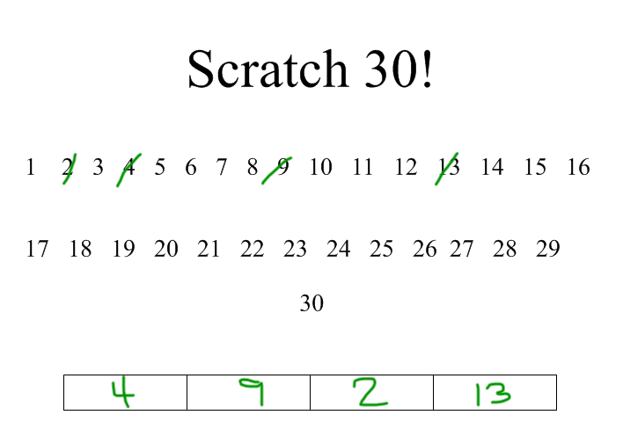
- Objective is to “scratch” off all the numbers.

Examples of equations:
4 + 2 = 6 (13 + 9) ÷ 2 = 11
(4 x 2) + 9 = 17 13 + 4 - 2 = 15

If you really want to be creative use exponents and factorials.

Factorials: pick a number, like 4 and multiply every number from 4 down to 2 together.
i.e. 4 x 3 x 2 = 24 In an equation, it would look like this: 4! ÷ 2 + 13 = 25

